# Import Anki card Layout:

If you did this already then you can go to “Import File into Anki for Anki cards”

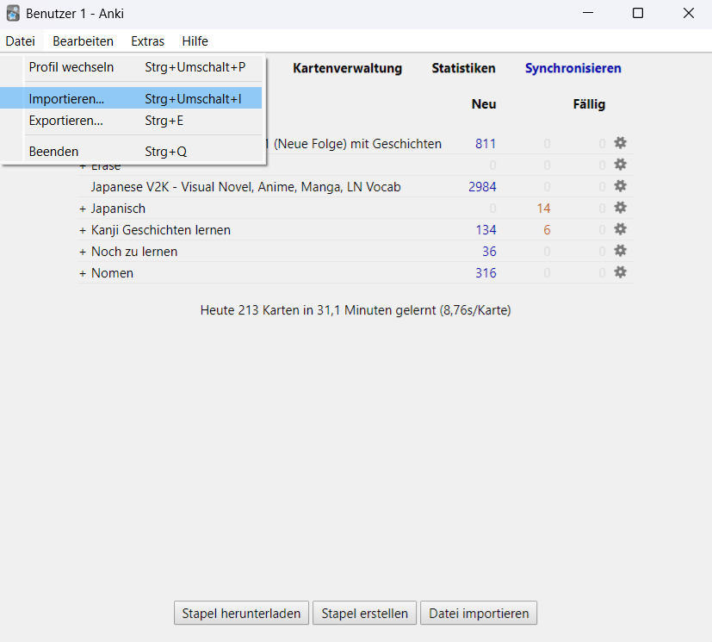

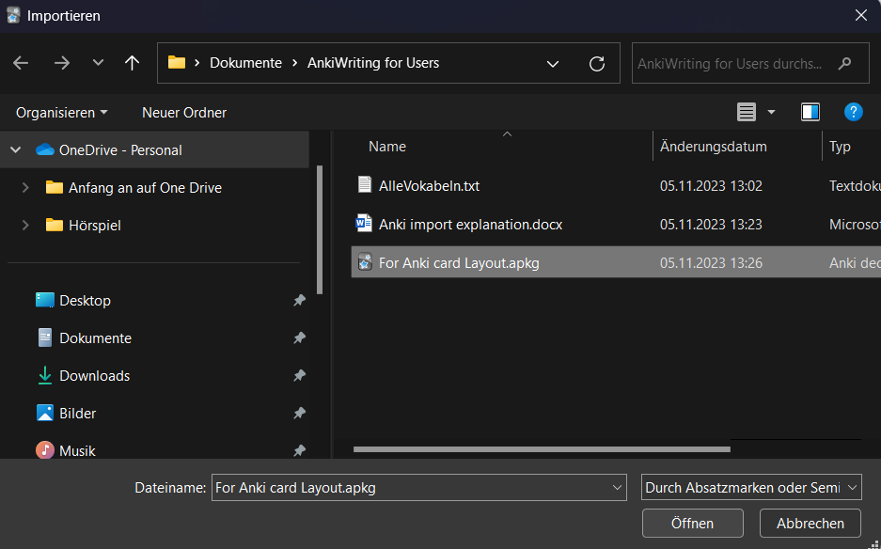

# Import File into Anki for Anki cards:

First go click on File 🡪 import…

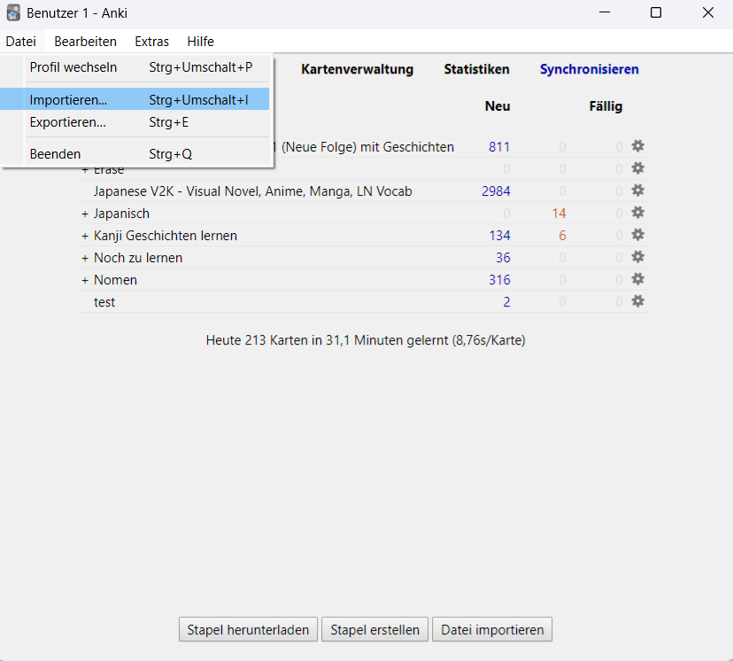

Now go in the chosen folder and open the file ‘AlleVokabeln.txt’.

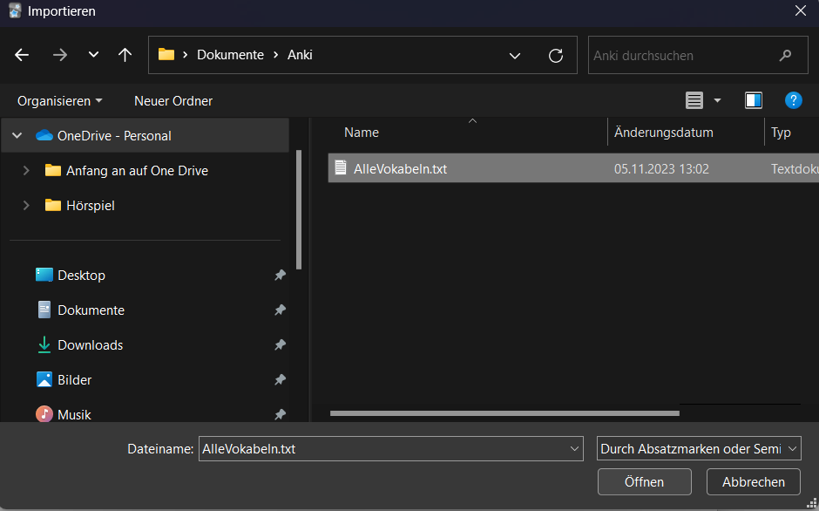

c

